SnowBird

2018-11-14

Raymond Knorr, Ali Rizvi,

Priscilla Chua, Zain Abedin,

Li Pan, Sana Khan

Milestone 4 – Lo-Fi Prototype, Usability Documentation, Progress Check-in

Continuing from our content strategy proposal, we decided to keep the idea of an ever-present nav bar with the four main headers: Committees, Course Material, Research Areas, and Forms/Documentation. This nav bar would also be on any of the nested pages within the private site. Since the private site would require a user to login, the site’s security would be tied to this authentication. This could either mean a base security level based on the user’s faculty, or specific permissions given to individuals. Included is a picture of the proposed login page, where the user would be directed to be authenticated. Once this is done, they will be taken to their faculty’s private site. The pictures of the Lo-Fi prototypes are labelled and included at the end for clarity.

The faculty’s private site main page will contain any information meant for just that faculty’s staff, as well as the aforementioned nav bar that contains the four headings. In particular, the Course Material heading will be a dropdown menu allowing the user to sort based either on professor or year, and the Forms and Documentation heading will allow the user to go directly to either the Faculty Specific Form page or the Documentation page. In fact, every page after the login page includes the nav bar with the four headings.

The first of the four headings will link the user to the Committees main page, which contains a list of faculty-specific committee items corresponding to individual committees. Each of these committee links will be a drop-down menu containing the option to either see the historical record of the committee members, or to see the past meeting notes. This page will also contain a link to a full list of all committees in engineering, where a user would be able to find a committee that would not be normally part of the software subdivision of the site. If the user decides to click through to Committee Members, they will see a list of years, each of which would link to a document detailing the members for that year. Similarly, if the user decides that they want to review the notes taken at a meeting, they will find them in the committee meeting notes section. Here, the meetings will be listed in reverse chronological order. It is also possible that the site would require some further classification of meetings based on the topics covered in them.

The next main heading included is the Course Material. As described above, it would either provide the user with a list of professors that would each link to another list of all courses taught by that professor, sorted by year. The other option available for the user is to simply view a list of all courses taught in the faculty, again sorted by year. Just in case the user wanted to view other courses as well, this site would include a link to a full list of courses taught in engineering.

In the Research Areas section, the user would view a list of professors. Each item in the list would include a short summary of the professors personal research areas. By actually clicking on the link, the user would be directed to a more detailed description of the professors research.

The Forms and Documentation heading dropdown has two options, the first of which would take the user to a Faculty Specific Forms page, where any forms needed by a member of that faculty would be included in alphabetical order. This page would also link to an exhaustive list of forms that would include any possible form that a general engineering user would need. The second option in the heading dropdown would link the user to a Documentation page. This page would include a list of folders, where each would be a specific area of documentation, such as ‘New-Hire Documentation’, or ‘Policy and Procedures’.

Besides Lo-Fi prototyping, we also developed a set of questions to include in a user questionnaire while testing the prototype. The questionnaire will be divided into three parts: pre-task questions, task questions, and post-task questions. Each of which will be explained in further detail with specific examples.

One of the purposes of a pre-task questionnaire is to collect what would be the closest to an unbiased opinion of the user’s experience. Specifically for our project, the navigation experience. The question we propose to ask is this: Do you think you would prefer to see more options on the same page, possibly decreasing legibility, with the advantage of having less click-throughs? Or would you prefer the opposite? This question will allow the tester to glean some insight from the user about how they like to navigate a webpage.

A task question actually requires the user to navigate the website. This provides the tester with a real-time view of how a user will interact with their product. A couple of our questions are as follows: Where would you go if you were searching for the content of a specific course? Can you attempt to find the page that would include ‘lab safety procedures’ documentation? The questionnaire should include enough task questions to adequately test the site’s navigation.

After the user complete’s all of the given tasks, the tester has the opportunity to ask any post-task questions that they have prepared. These are able to assess the users experience of the structure and navigation. Some of the questions that we had prepared are these: How would you rate your ability to navigate the pages on a scale from 1-10? What is the most important feature that you think is missing or that we need to add? Are there any parts of the web page structure or navigation that did not make sense? These three questions are geared to get user input about the actual product.

Our group did not extensively test the usability of the Cascade Server, however, we noticed that a lot of the functionality is similar to the public site investigated in Milestone 2. This includes the presence of the navigation path on each page, as well as the frequent use of dropdown menus.

Picture 1: Login Page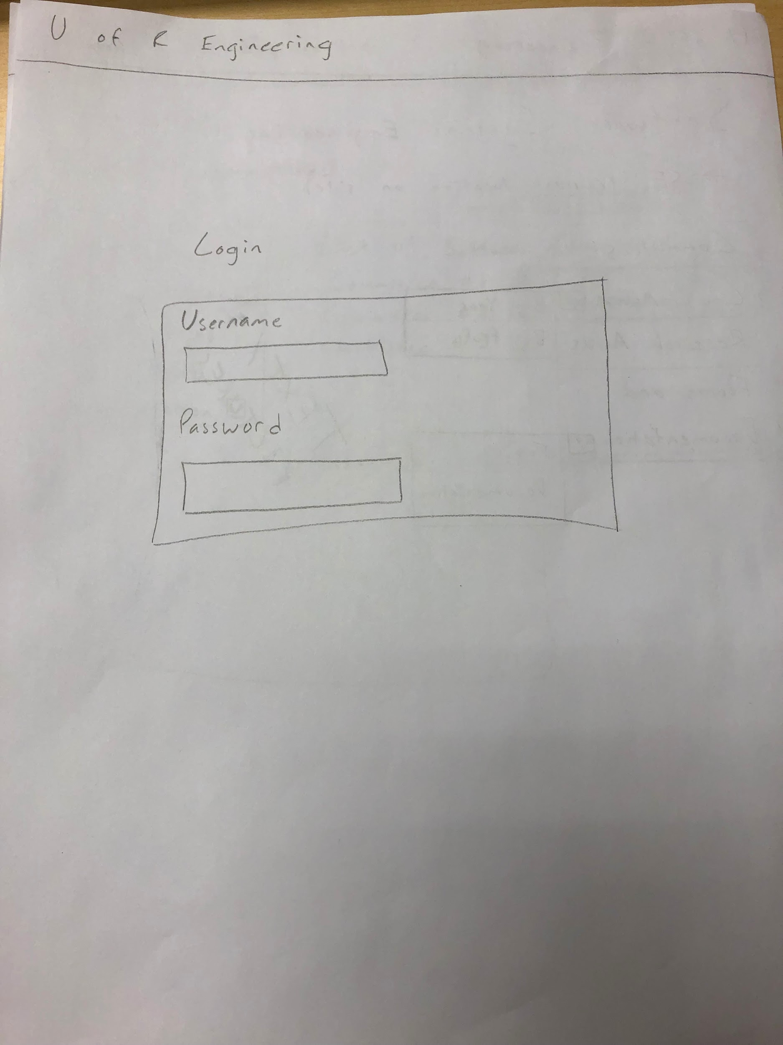

Picture 2: SSE Main Page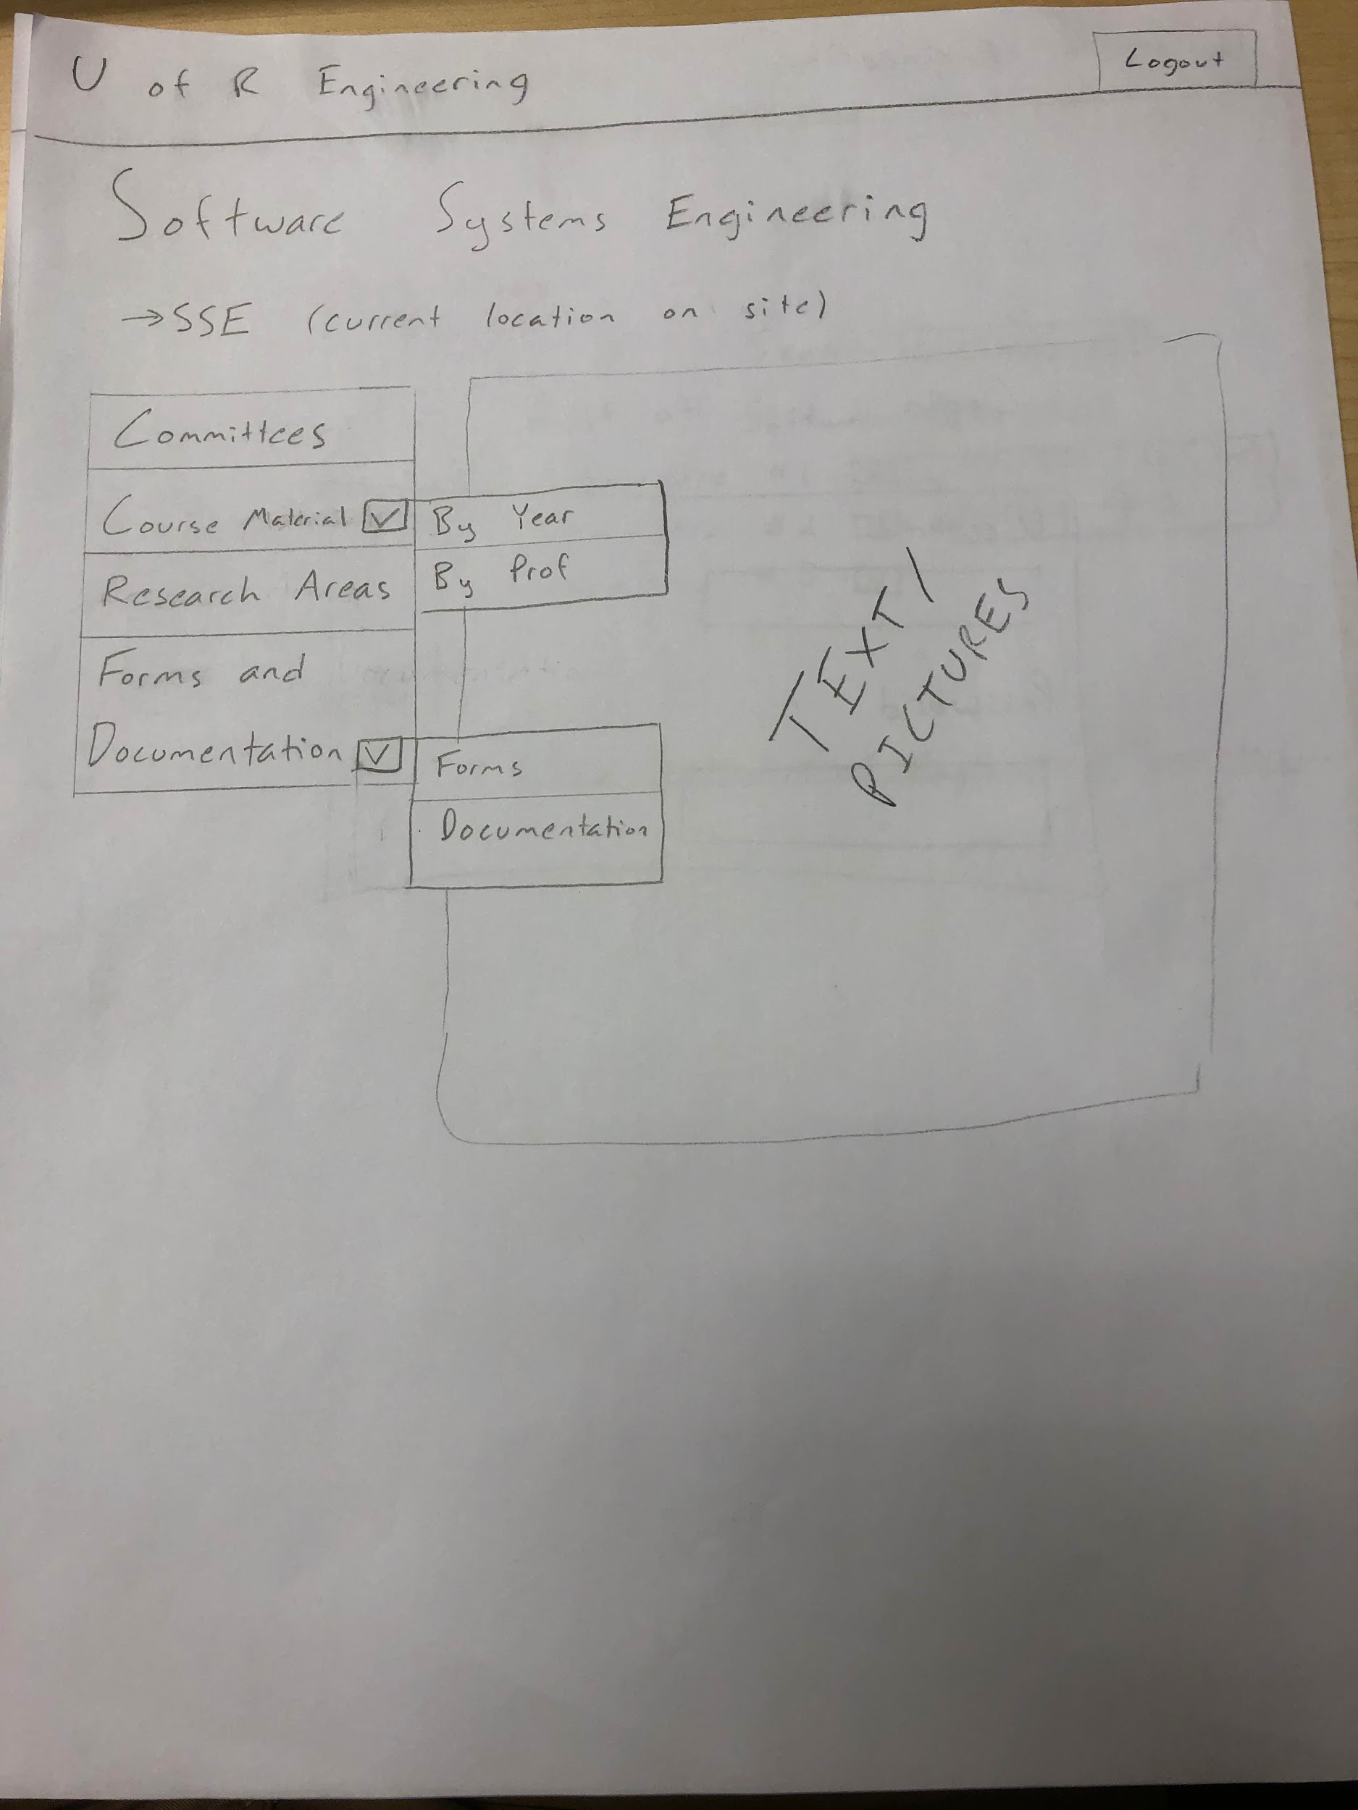

Picture 3: Committee Section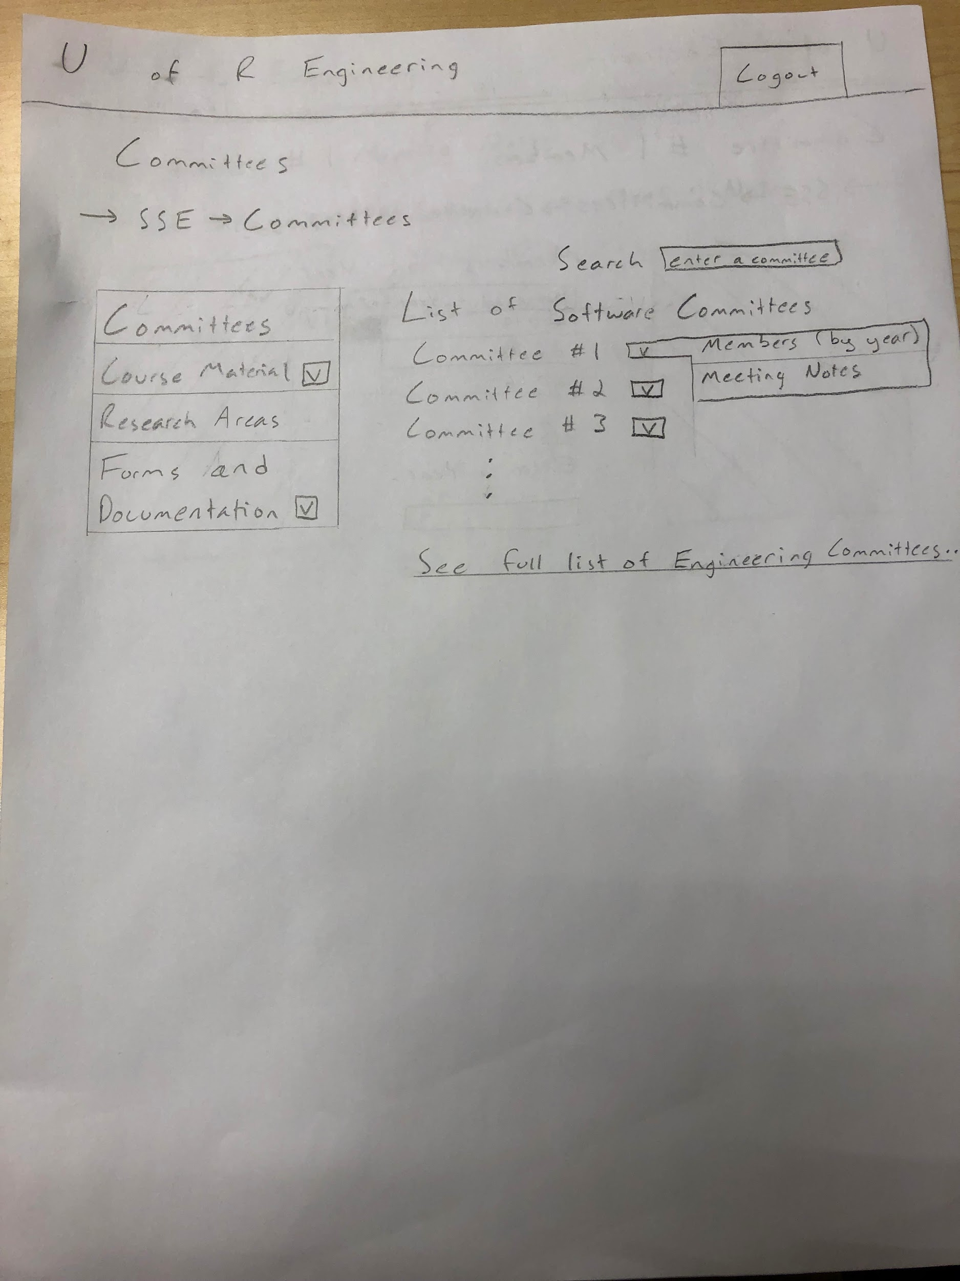

Picture 4: Committee Members by Year 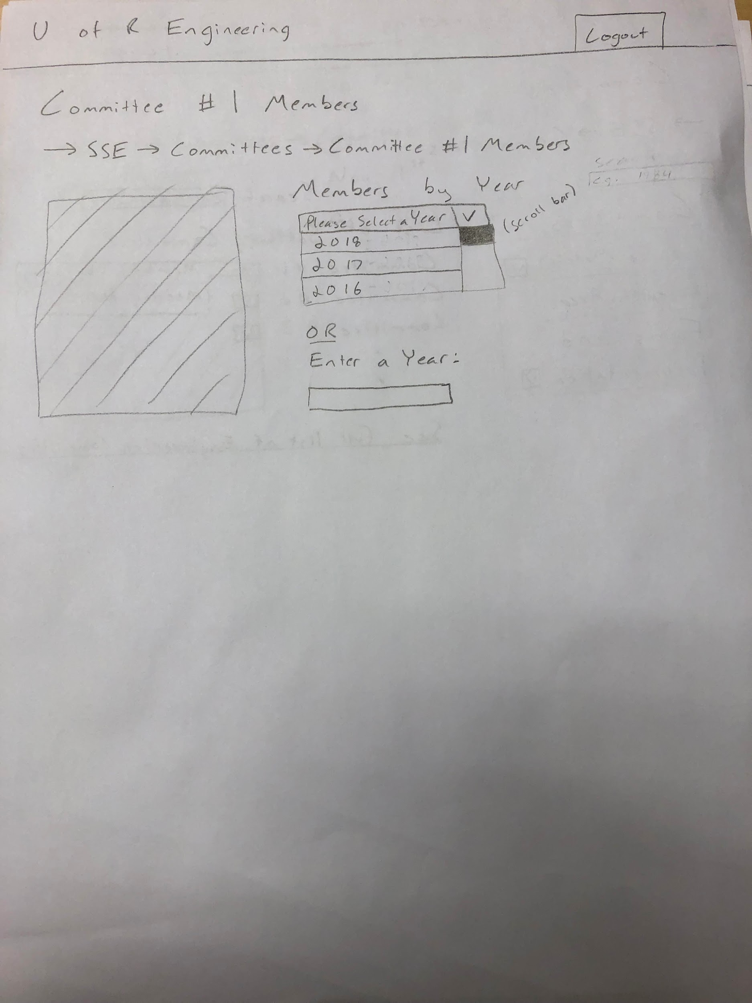

Picture 5: Committee Notes by Date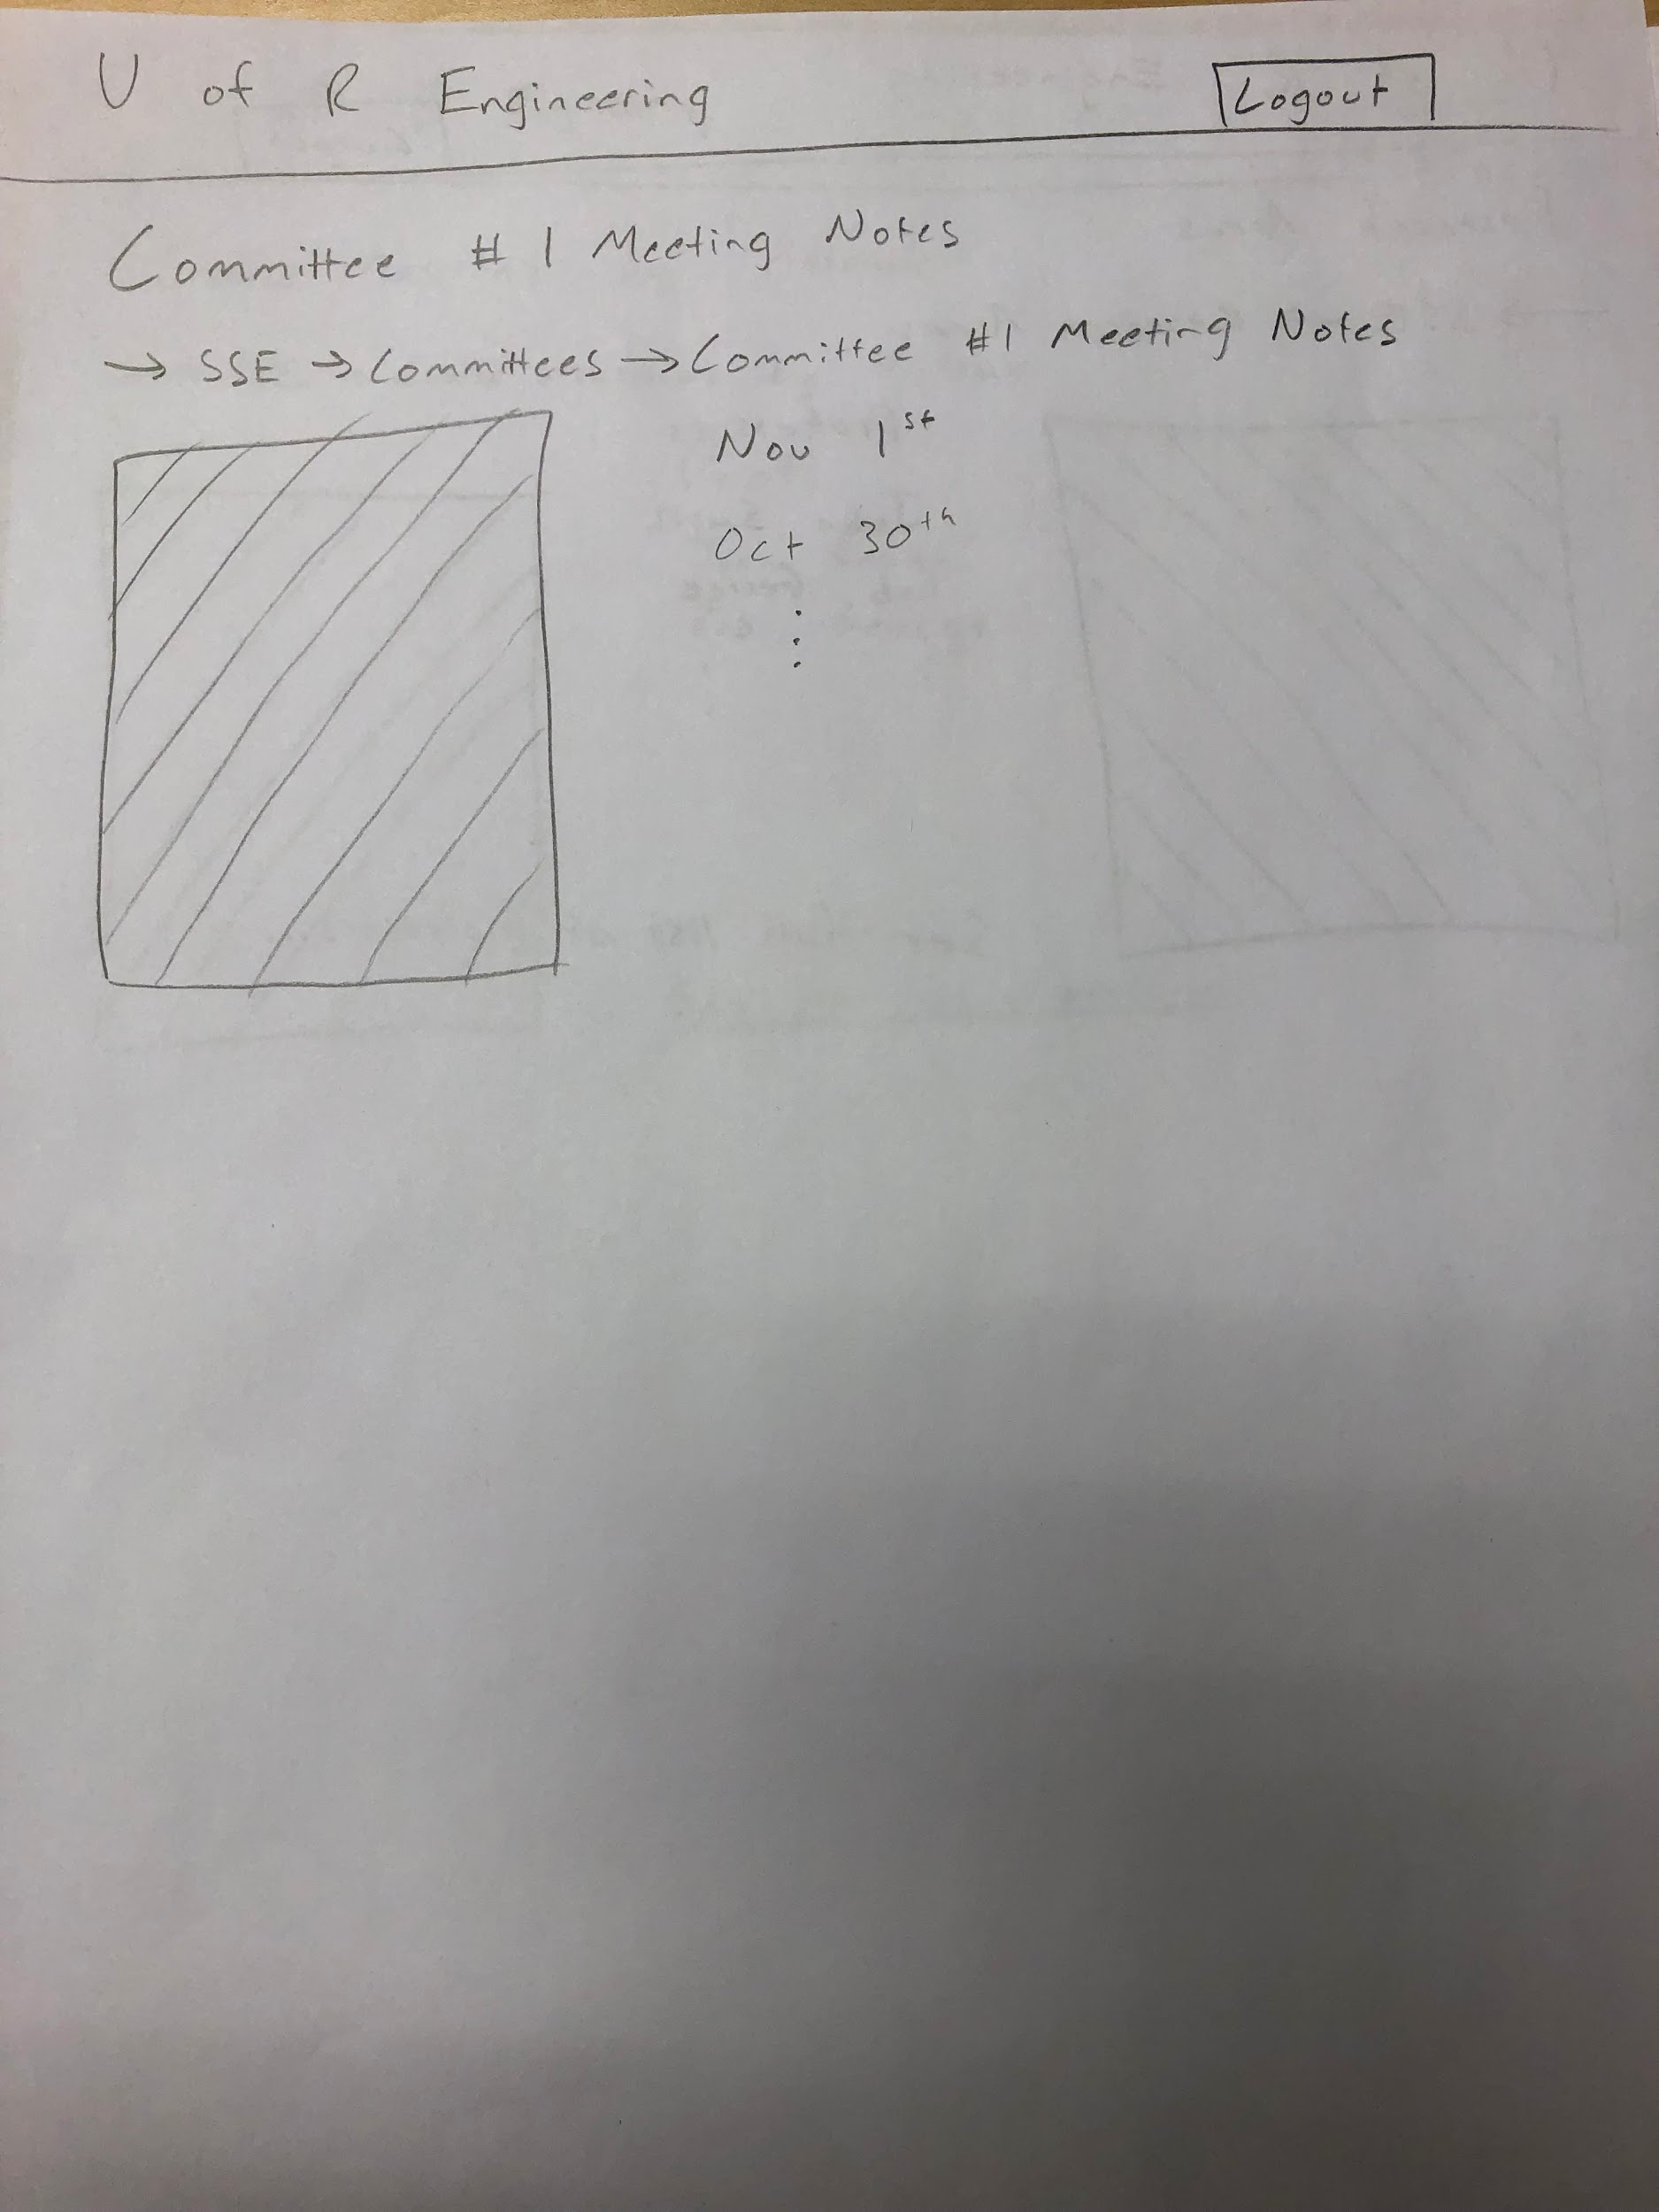

Picture 6: Research Areas 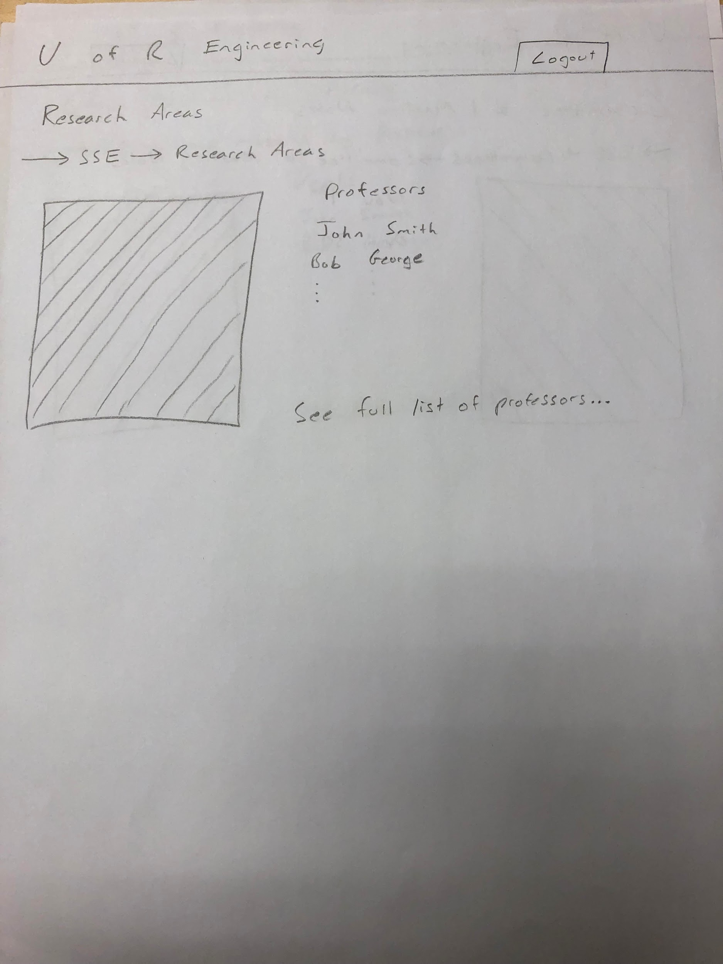

Picture 7: Course Material by Professor

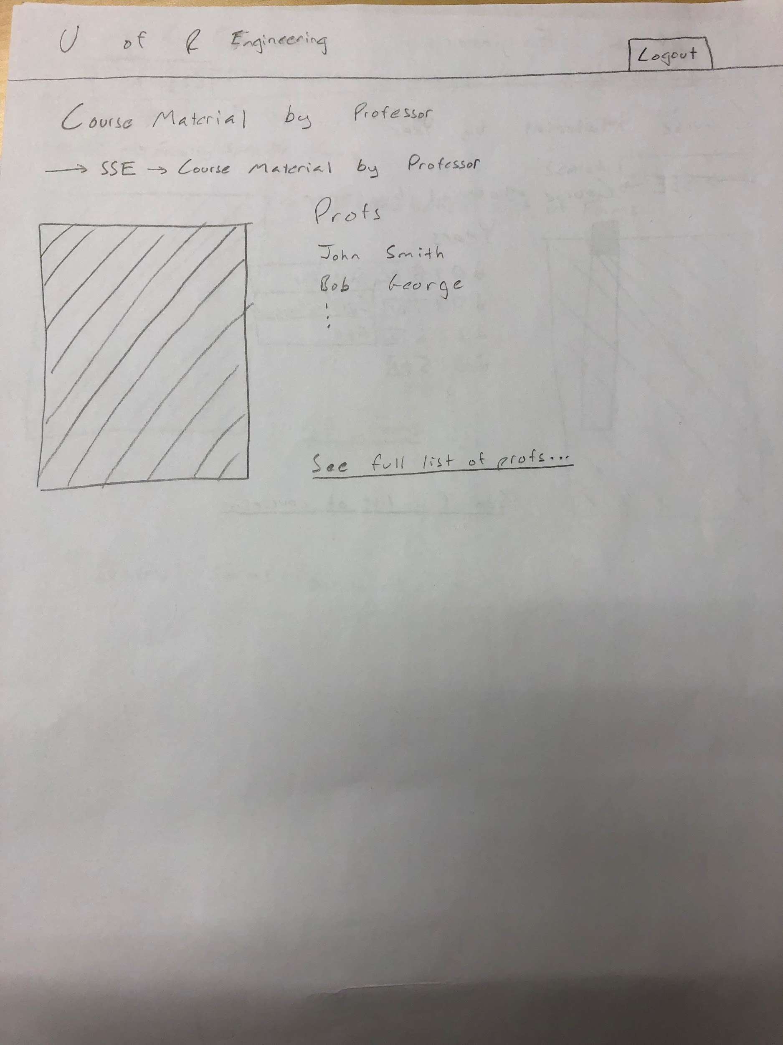

Picture 8: Course Material by Year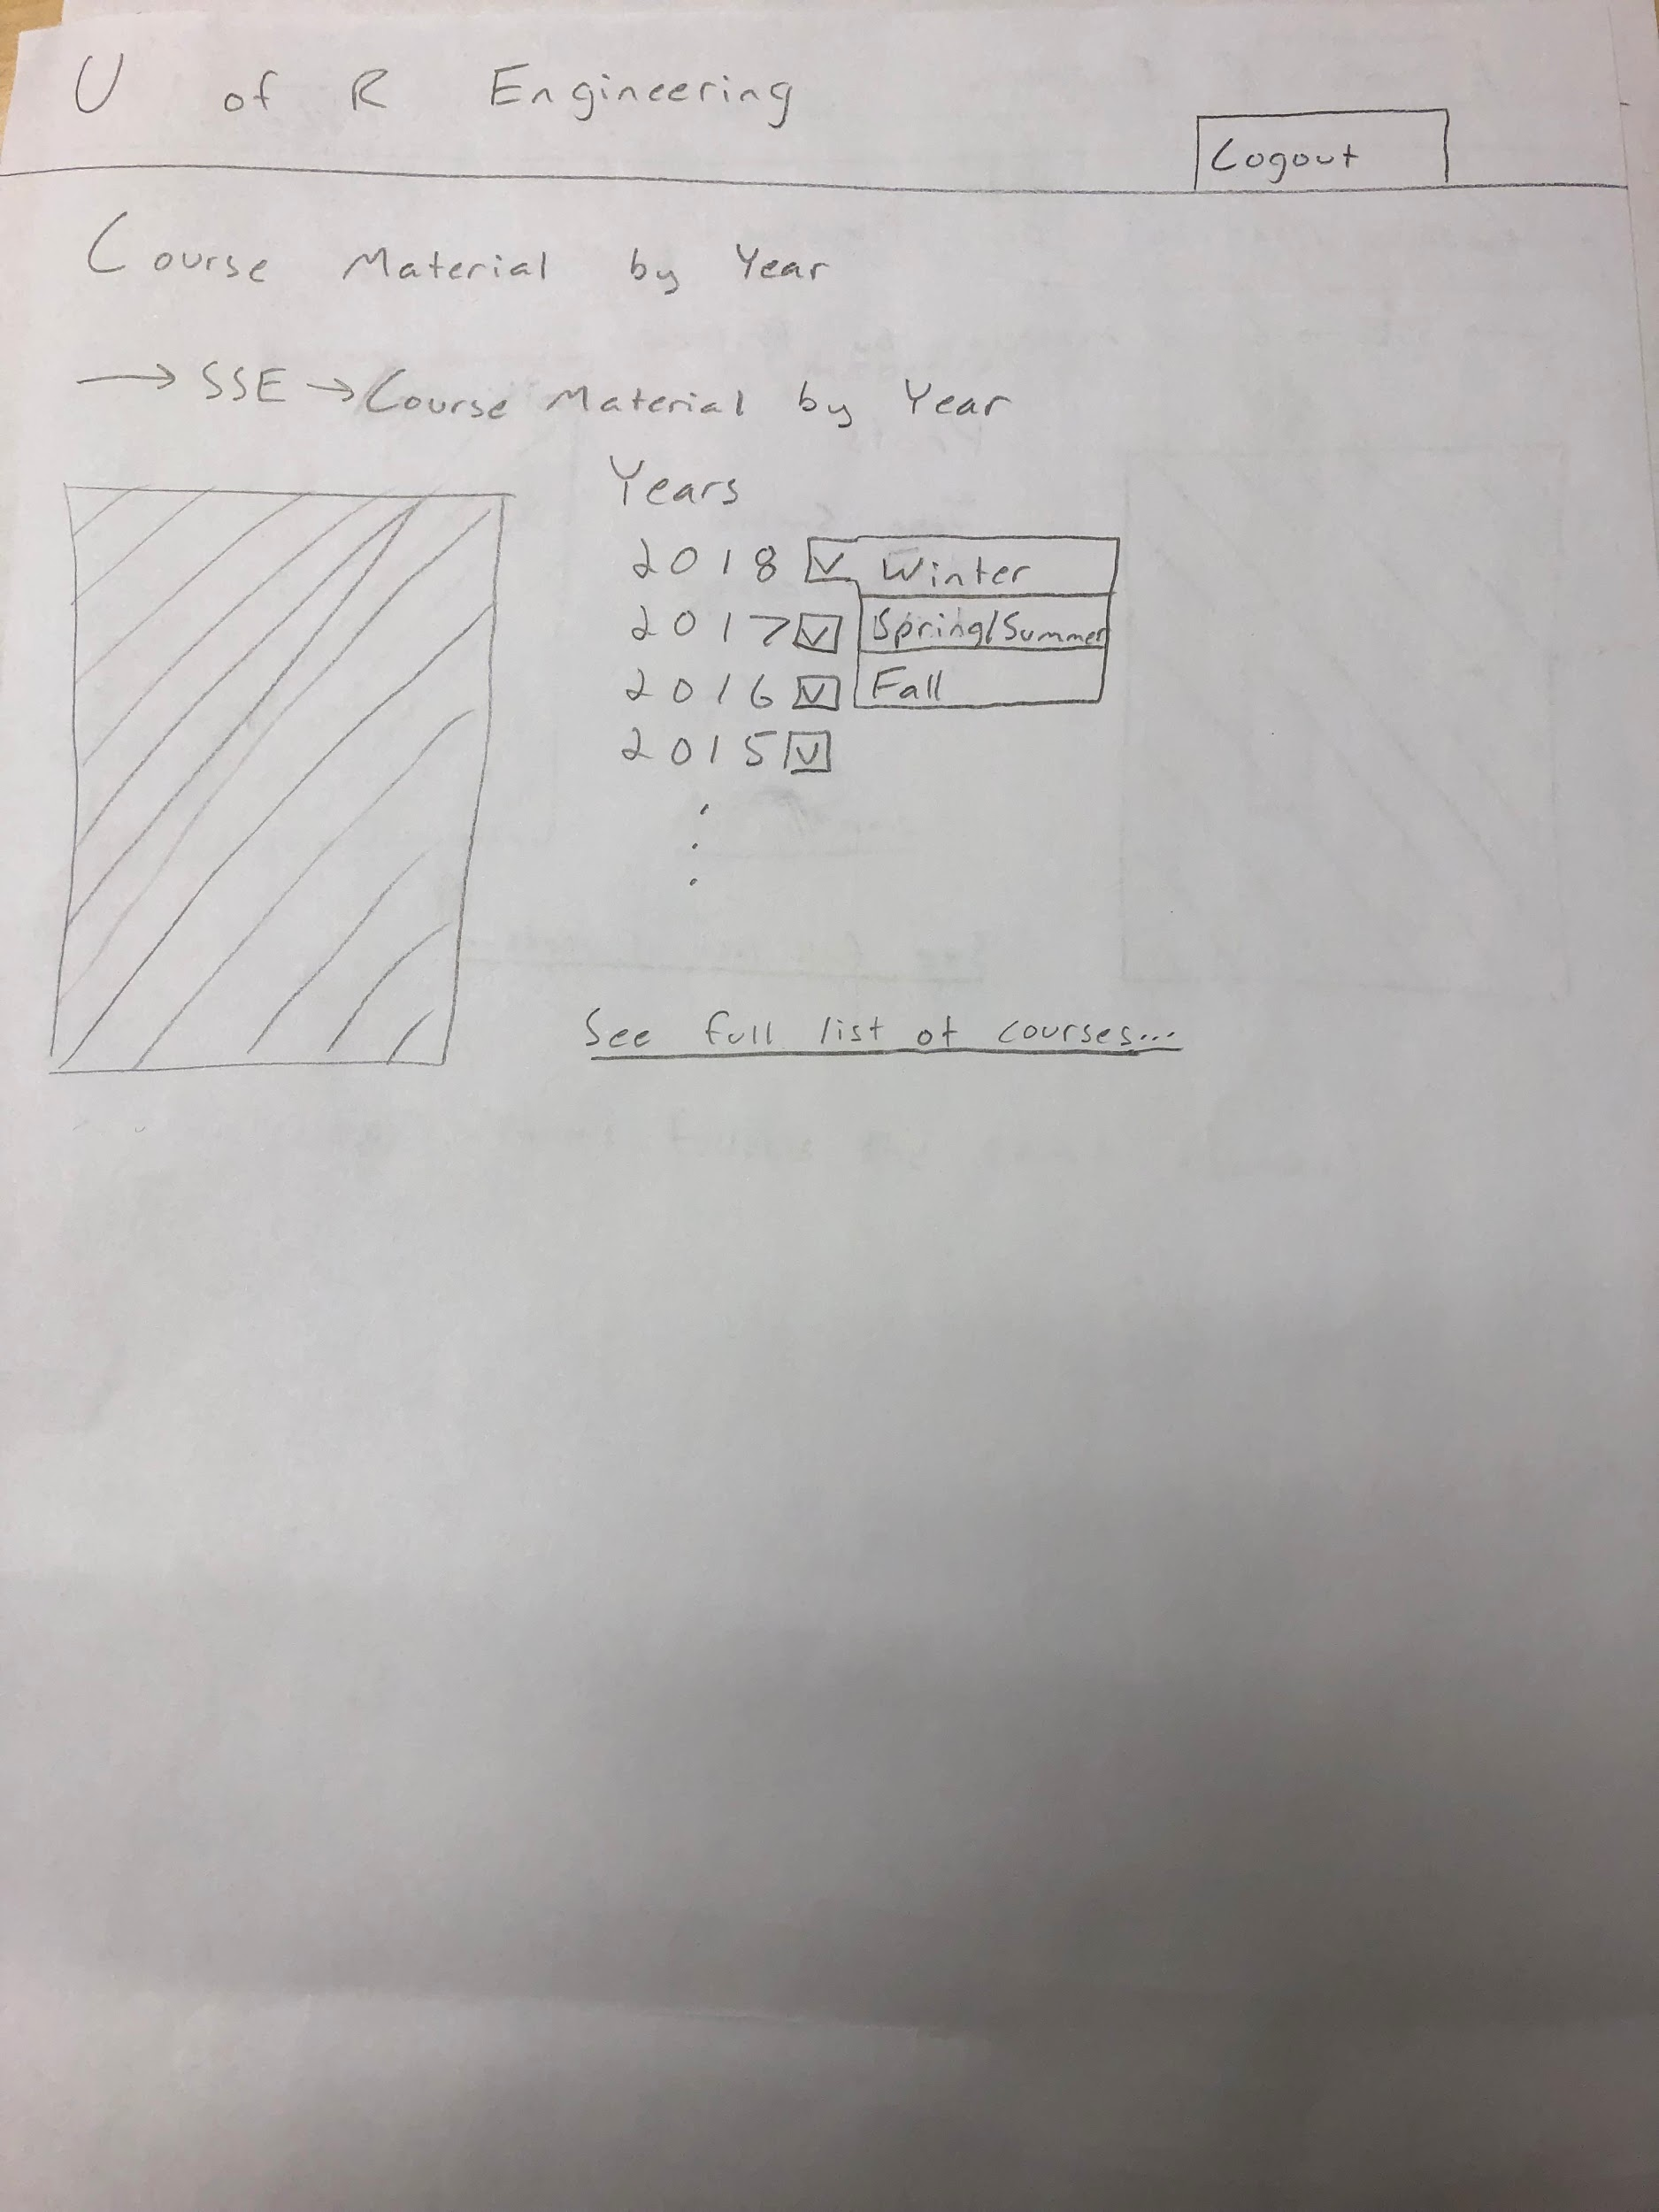

Picture 9: Faculty Specific Forms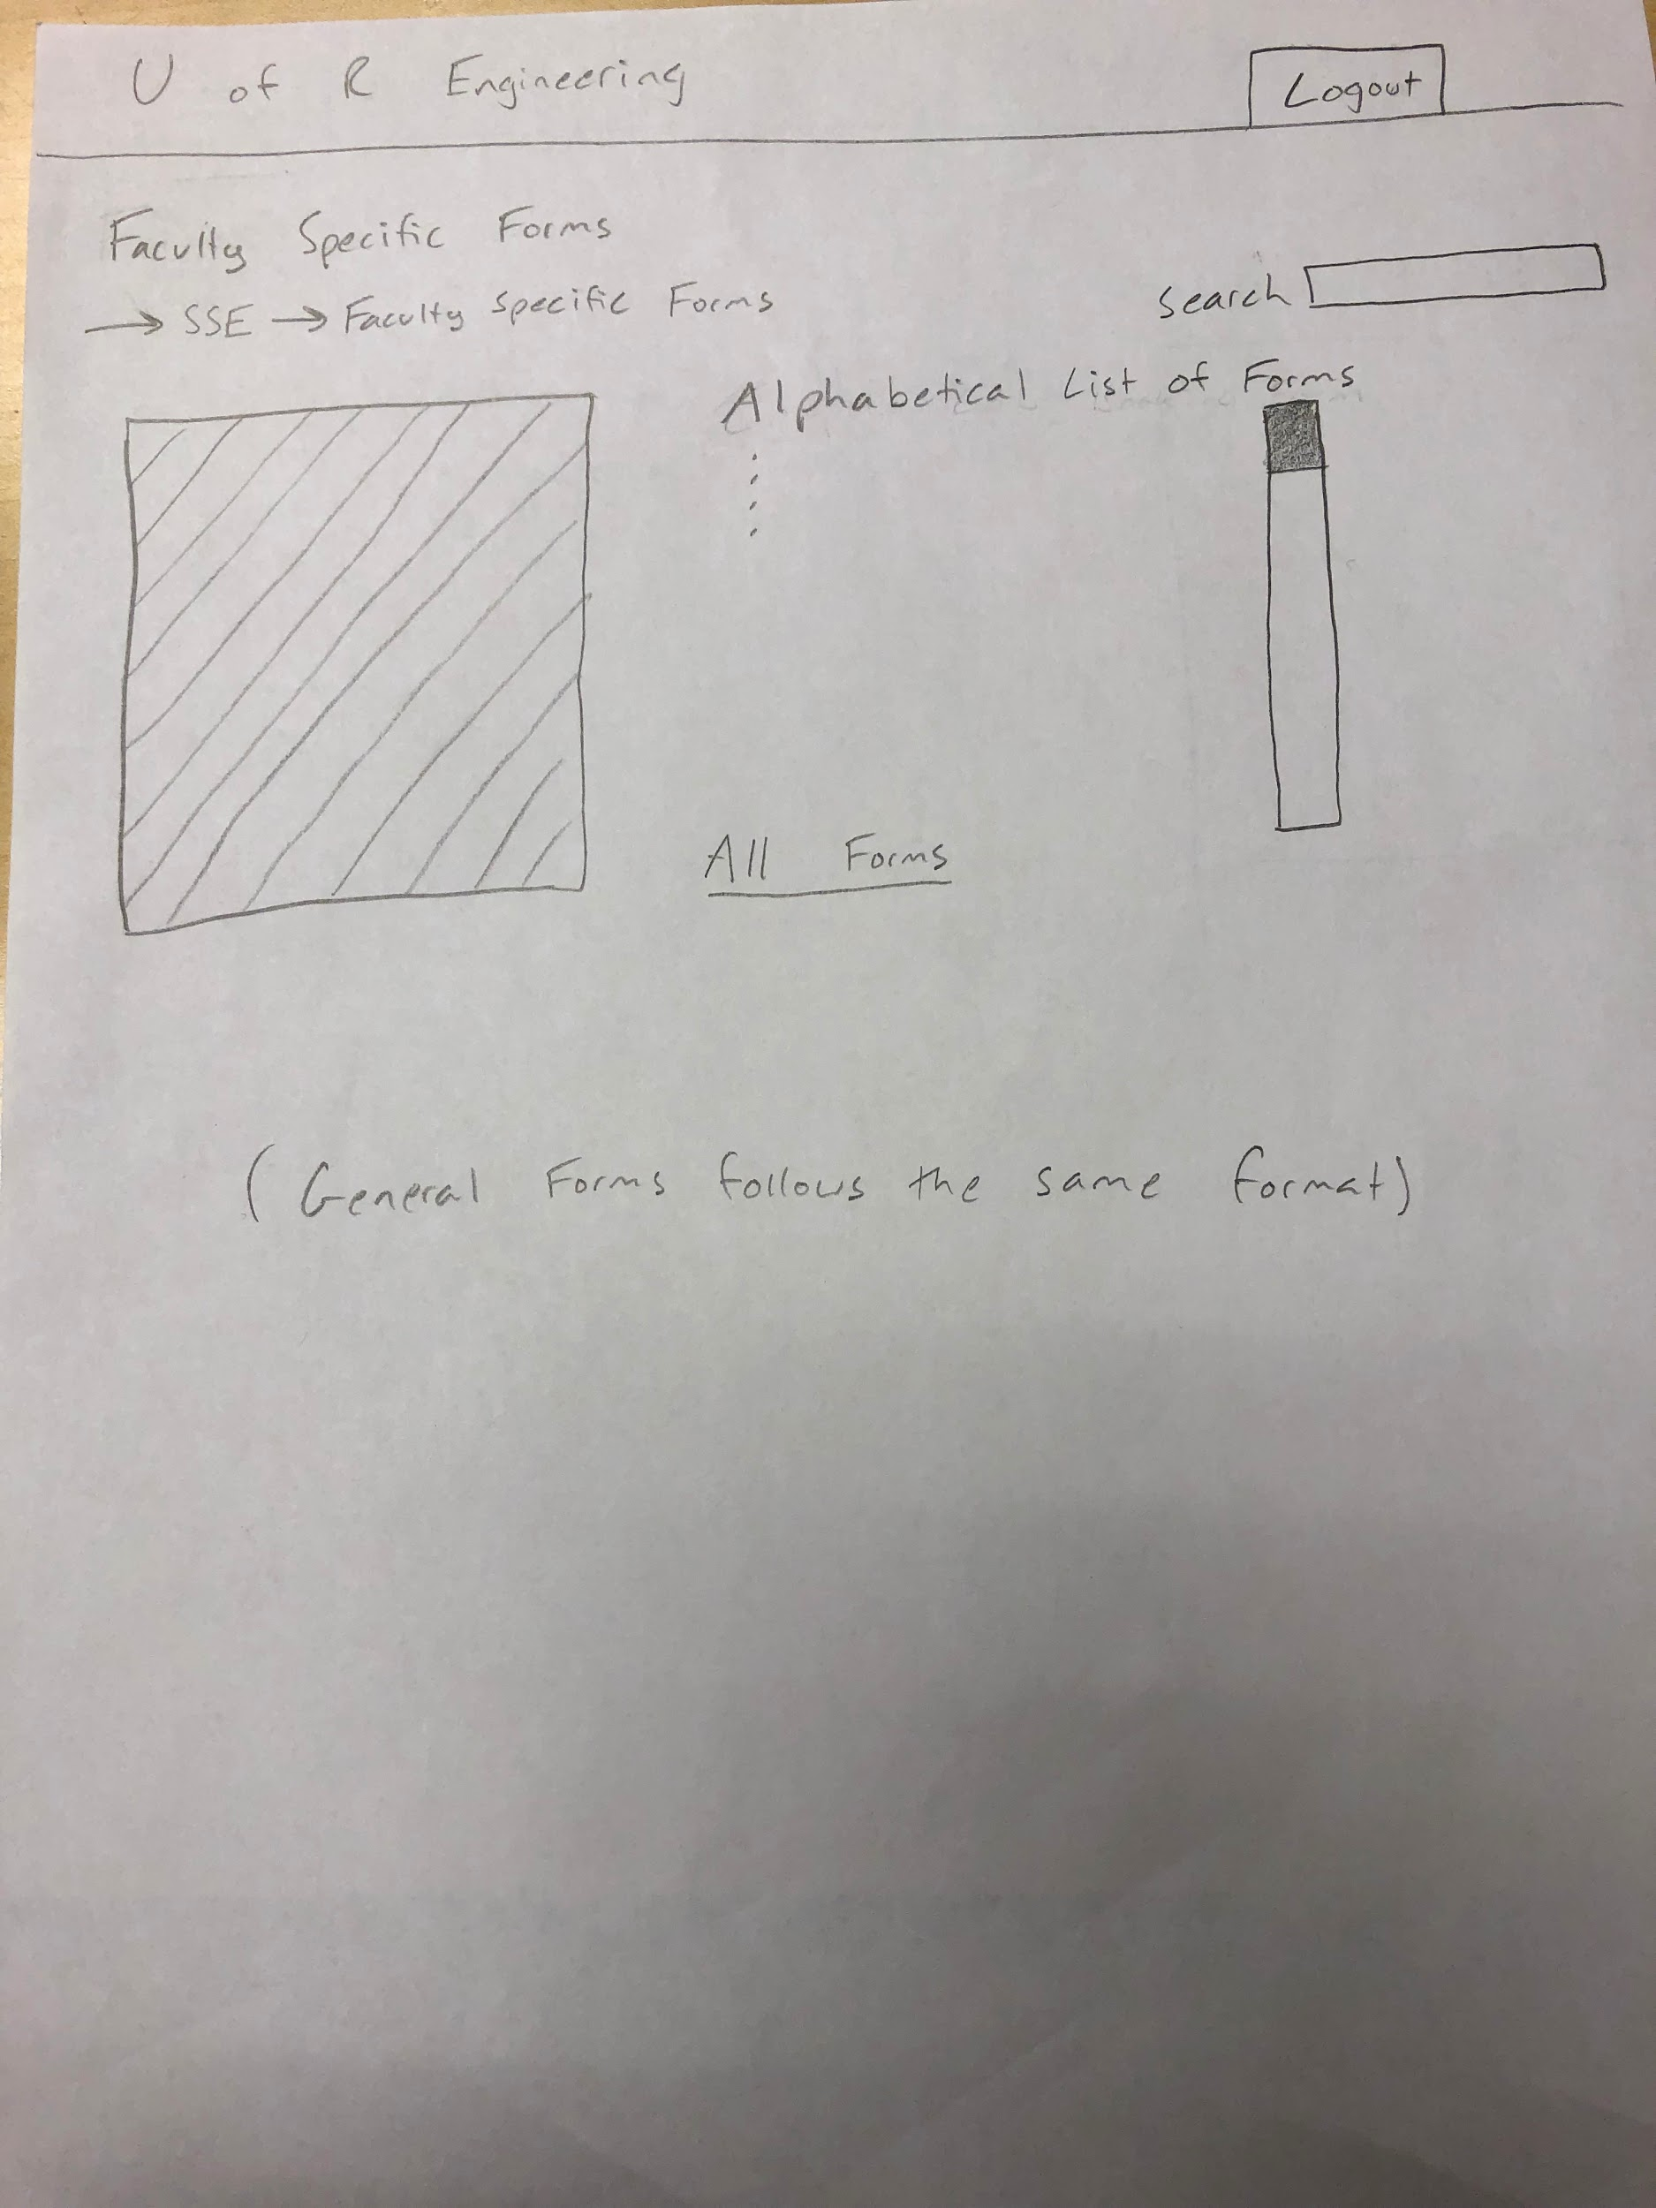

Picture 10: Documentation